


Shoubra Faculty of Engineering
Benha University
Student Name: Mohamed Ahmed Fathy Abdel-Fadeel
Group: 5
Section: 29
Student ID: 651
Github Link:

Project Title :
Artificial intelligence

Under Supervision of :
Dr. Ahmed Bayoumi

Introduction :
What's the website of topic I choosed?
This website contains five pages that are built with Html language. The website discusses Artificial intelligence, its ideal characteristic and effects in real life (the simulation). The website is also included some professional and interactive pictures and reference links.
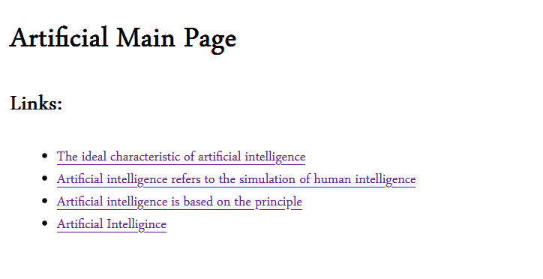
What I choosed this topic specifically?
The reason for choosing this topic is that the world is on the cusp of a new revolution that will change the shape of human life led by Artificial Intelligence, and it is a comprehensive revolution at various levels, security, economic, social and others, because the applications of Artificial Intelligence are numerous and increasing in a way that is difficult to count, it almost enters into all human fields, and even At the moment, no objective conception or evaluation of the repercussions of these applications has been developed, especially with the division of these applications between civilian and military applications, and their repercussions differ in each of them. Rather, it can be said that some civilian applications of artificial intelligence, which are supposed to make the lives of individuals easier and faster, such as The pattern of smart cities that combines all the technologies of Artificial Intelligence systems, may be a reason for increasing the power of machines over human life.

The First webpage
(Artificial Main Page) :
This page contains links collection that shows Paragraph's titles about Artificial Intelligence.

The Second Page
(Ideal Characteristic) :

This page contains the Ideal Characteristic of Artificial Intelligence & Electronic Software Intelligence & what to can do in this field about that everyone needs to know.

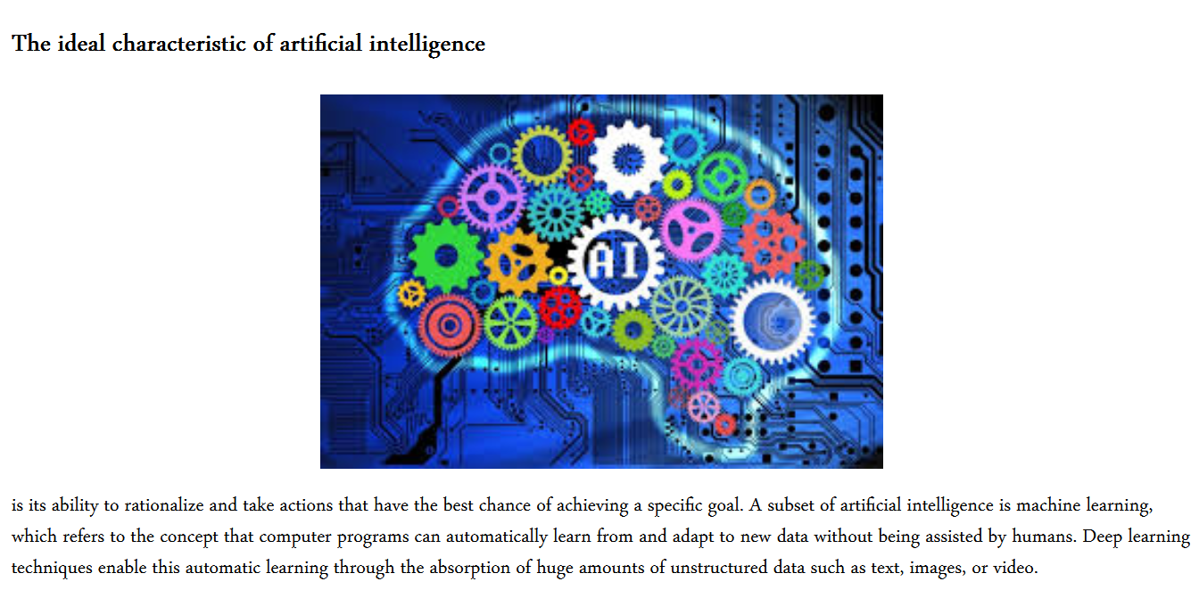
The Third Page
(The Simulation Of Human Intelligence) :
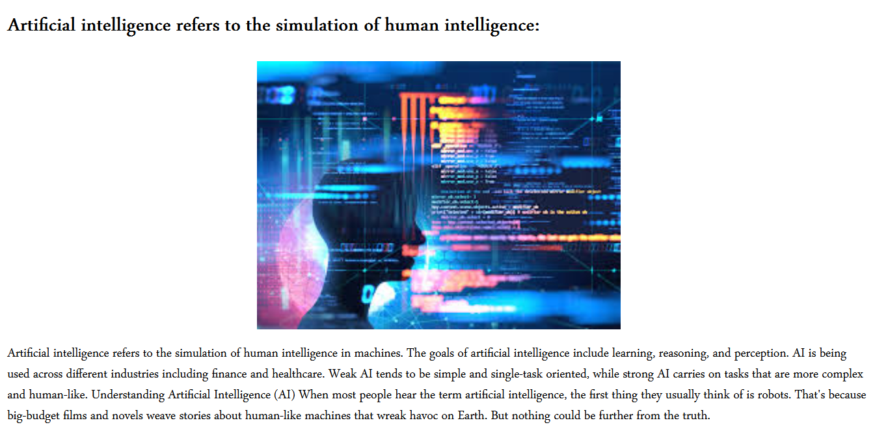This page shows that how far Artificial Intelligence is close to the human Intelligence including robots, and that we see a lot (in labs, films, shops, etc..) ; It's an amazing project.

The Fourth Page
(what does Artificial Intelligence base on?):
Artificial Intelligence depends on The Principle. The Principle is considered the backbone of Artificial Intelligence.
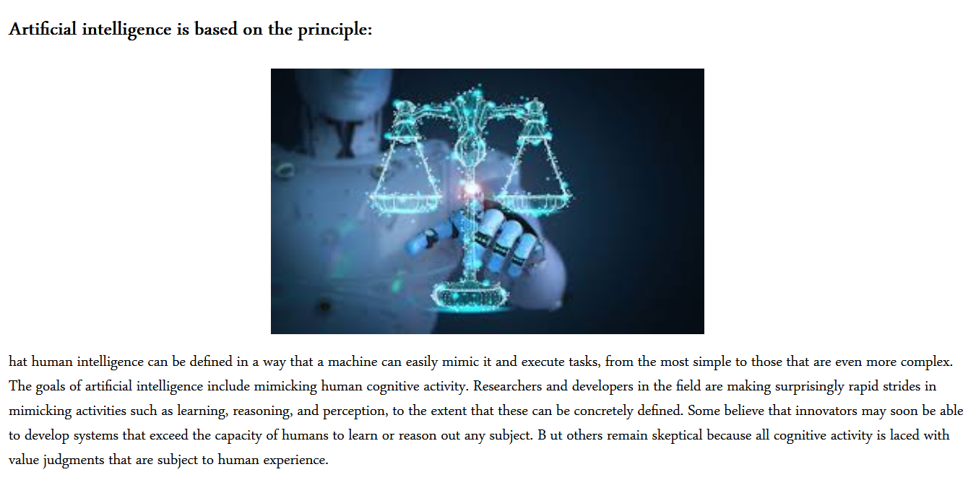

(SOURCES) :
- Investopedia
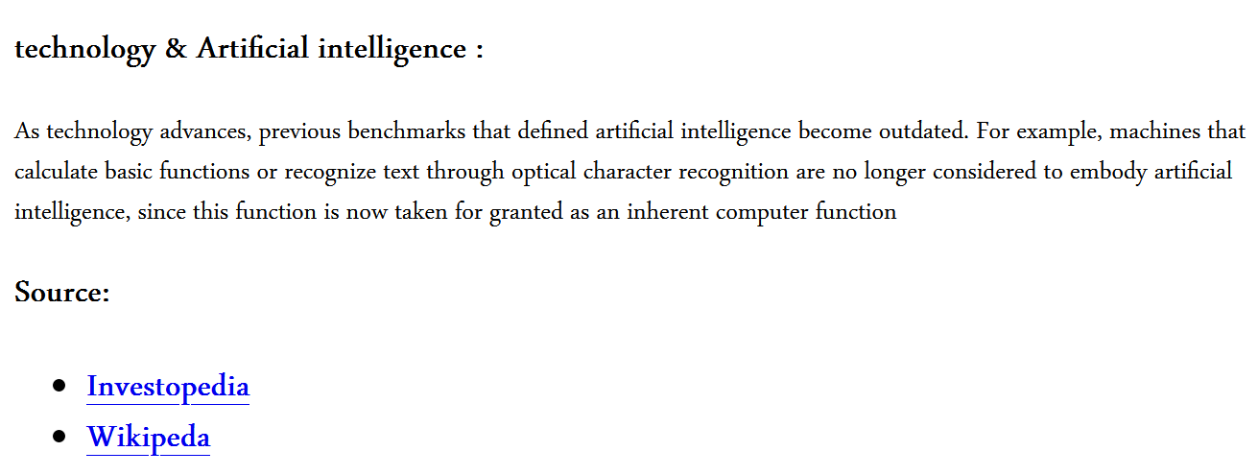
- Wikipedia

The Fifth Page
(What Is Artificial Intelligence):

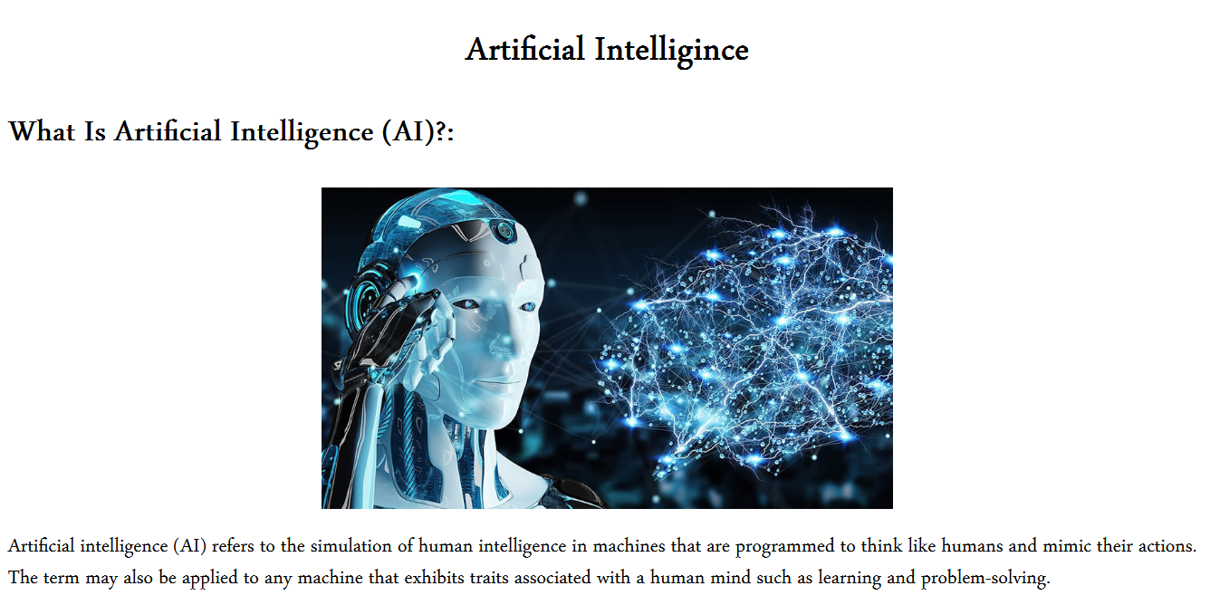
(Code in Html):
- This is the code of "Artificial Intelligince" :
<html>

<head>

<title>Artificial Intelligince</title>

</head>

<body>
<center>
<p>
<h1>Artificial Intelligince</h1>
</p>
</center>
<p><big>
<h2>What Is Artificial Intelligence (AI)?:</h2>
</big></p>
<center>
<p><img src="https://amayei.nyc3.digitaloceanspaces.com/2020/12/190605-artificial-intelligence-i-think-therefore-i-am.jpg"
width="400" heigh="400" </p>
</center>
<p><big>Artificial intelligence (AI) refers to the simulation of human intelligence in machines that are programmed
to think like humans and mimic their actions.
The term may also be applied to any machine that exhibits traits associated with a human mind such as
learning and problem-solving.</big></p>
</body>

</html>

- This is the code of " Artificial Main Page " :
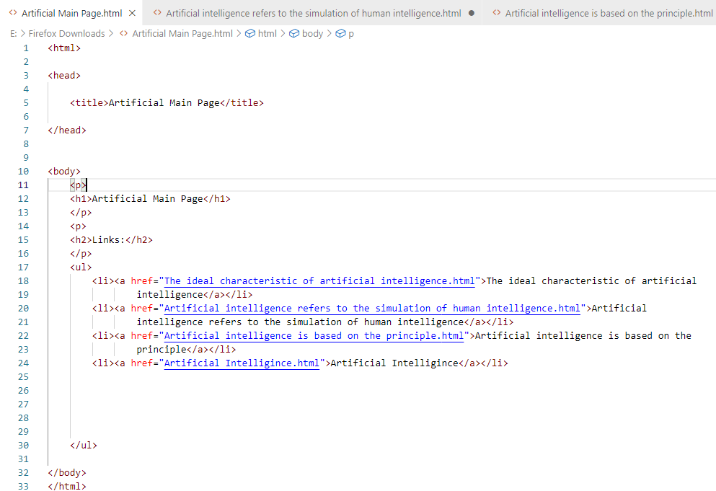
References :

Investopedia

Wikipeda

